Web Network Load Balancer
Design Document 1

Version 1.0



Supervisor Name: Mr. Tanweer Arshad
Student Name: Faheemullah Memon
Student ID: MC070402736

Revision History

Date (dd/mm/yyyy) | Version | Description | Author
30/11/2012 | 0.1 | Initial draft | Mc070402736
4/12/2012 | 1.0 | Finished and reviewed | Mc070402736

Table of Contents
Revision History 2
1. Introduction 4
2. Overview 4
2.1. Network Load Balancing Techniques 6
2.1.1. Transport Level Network Load Balancing 6
2.1.2. Application Level Load Balancing 8
3. Data Flow Diagrams (DFD) 12
4. Entity Relationship Diagram (ERD) 14
5. Activity Diagram 15
5.1. Request Routing 15
5.2. Configure System 16
5.2. Round-Robin Router 17
6. Sequence Diagrams 18
6.1. Process a request using round-robin router 18
6.2. Add Application 19
7. Architecture Design Diagram 20
7.1. Architecture design diagram component details 20

1. Introduction
Every product, software or otherwise, is always developed to solve a particular problem. Or to address a certain limitation that exists with current way of doing things. So in essence, from a cause-and-effect scenario, software is an effect and it can’t be done right without fully understanding the “cause”. Understanding the “cause” is crucial and is covered in the analysis phase.

In analyzing need for a network load balance software application we noted that with ever increasing internet users and limited hardware and network resources it’s inevitable to develop these intelligent systems. In SRS document we also went over the details of such a system, like dynamic vs static content delivery networks (CDN’s), system monitoring and health requirement and several abstract models of designing these systems.

This document elaborates and illustrates the abstract ideas introduced in software requirements specification document. Design is another important step of software development life cycle. A good design encapsulates the user requirements and provides an overview of how the system is going to work. Design serves both as an outline of the system and as well as an insight into the software system. Outline helps us maintain the scope of the software and insight gives out enough details for implementation that the work can be carried out.

Design can be done with several tools for different kinds of abstractions. Since this step precedes the implementation, it provides a point to reconcile with all the stakeholders. Using the right kind of modeling tool and abstraction the design can be communicated to the stakeholders.

2. Overview
In order to meet high availability and scalability demands on web servers, system administrator can deploy scale up or scale out techniques using software or hardware components. Scale up technique requires beefing up the single web server hardware to meet the high traffic demand. Faster and more fault tolerant hard disk devices, network infrastructure, and more CPU cores. Scaling up is a temporary solution and is mostly address the server load issues, scalability. When it comes to high availability or serving even higher number of users scaling out is the correct solutions.
Scaling out means creating a server farm infrastructure where bunch of different server machines, software systems, and network infrastructure work together in serving the web traffic through a single unified interface. Scale horizontally across more nodes. This server farm is invisible to the end users and they still interact with the same website using same internetworking protocol stack. Scaled out architecture means servers can be added and/or taken out based on traffic patterns and solution provider preferences. Scaling out requires specialized software or hardware to combine that entire infrastructure under on monolith interface and it’s called server load balancers.
Server load balancers split processing from incoming traffic to different back-end servers. Backend servers actually process the request and send results back to the clients. These systems and their configuration has to follow the TCP/IP and HTTP feature set in order to serve the requests accurately and smartly. HTTP applications that provide session support are called dynamic applications. Dynamic applications keep track of their client state to allow them to interact with the website as single identified user throughout multiple page requests. It’s important for a network load balancing software to off-load incoming traffic for dynamic applications in such a way that a given client is directed to their session carrying server every time.

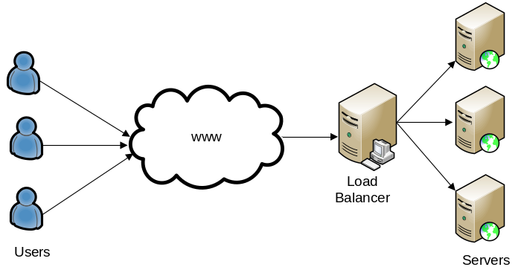
Figure 1

2.1. Network Load Balancing Techniques
There are several ways to achieve network load balancing including both hardware and software solutions. All these techniques have their benefits and flaws in certain aspects are other. In this section we are trying to provide an overview of these methods and do some basic comparative analysis. This project is a software solution so we will talk more about it in following sections.

2.1.1. Transport Level Network Load Balancing
In transport level network load balancing, traffic splitting is done at lower levels of TCP/IP protocol stack. This mostly achieved by software inside routers and switches. These solutions don’t go into application protocol level and route packets based on the transport level information like IP address and DNS resolution.

2.1.1.1. DNS-based Load Balancing
DNS based load balancing is basic way of achieving network load balancing. In TCP/IP protocol stack, administrators can assign human readable names, called host names, to internetworking addresses which are mostly numeric and binary. By assigning name to address it’s easier to refer to the service when required. Like a user can type “google.com” in a browser translates that address to actual numeric address and then fetches the contents from that server. The translation from hostname to numeric IP address is done with help of a specialized service called Domain Name Service or DNS for short. These DNS’s are the interconnected registers on the internet or intranet that keep track of all the names and numeric IP address. These names are categorized based on their purpose. The one we are talking about is called an “A” record or a host record.
DNS servers allow administrators to assign multiple IP addresses to one host name record, see NSLOOKUP results in Listing 1 for example:
Listing 1:
>nslookup google.com
Server: resolver1.opendns.com
Address: 208.67.222.222

Non-authoritative answer:
Name: google.com
Addresses: 2607:f8b0:4004:80d::200e
63.88.73.58
63.88.73.59
63.88.73.57
63.88.73.53
63.88.73.54
63.88.73.52
63.88.73.55
63.88.73.56

As you can see “google.com” host has three IP address matching. If DNS server has implemented a round-robin approach, it will resolve to a different IP address each time it’s contacted. Web browsers normally contact DNS first time when they are resolving a hostname and they tend to cache and reuse that resolution result. That way load is shared among three different servers or server clusters and user session state is also kept intact. This technique does not require any additional hardware or software components.
DNS based load balancing is efficient and is useful in distributing request to several data centers. It’s normally used in combination with other load balancing techniques that then split traffic inside those data centers or server clusters. This technique is not used extensively because of its lack fault tolerance and robustness. As we know that client browsers tend to cache the resolution from first query for reuse, if that resolved server node goes down for some reason, service will be unavailable to the client. All subsequent requests to that host name will fail for this client and browser will not try to resolve the address again by itself.

2.1.2.2. TCP/IP based Load Balancing
TCP/IP based load balancing is mostly achieved by using specialized internetworking devices like router or switches. There are several ways to achieve this type of load balancing but most common form of it is called network address translation. A single node resides on top of a server cluster that receives all the traffic from users in an asymmetric fashion. These nodes then split incoming IP packets to the back-end servers configured in the cluster. These devices normally use round-robin or module ip-hash based algorithms to select the appropriate server. They change the source the address of the routed packet to their address so that the request routes back through the same node when resolved. That way the client server doesn’t know internal cluster structure and is always served by same host. This switching of address is called networking address translation.
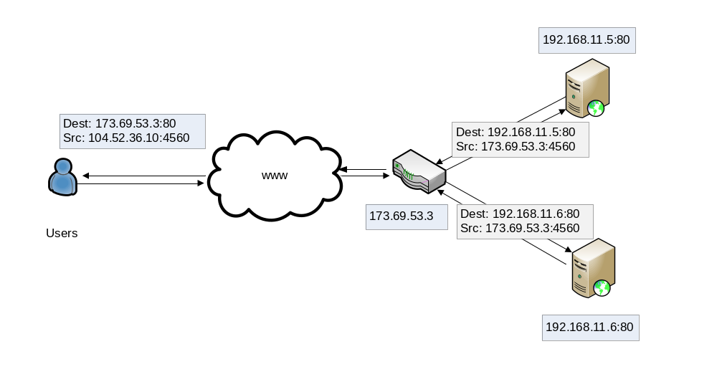
Figure 2
Since TCP/IP based load balancing works on lower level it’s well suited for static applications, however, it doesn’t bode well with dynamic applications that require a little more data intelligence in routing. IP hash based technique does provide some level of client affinity or stickiness but it fails short if a server goes down or another one added to the configuration. We will analyze IP-hashing this further in following sections.

2.1.2. Application Level Load Balancing
Application load balancers work on the application protocol, like HTTP or FTP, level in TCP/IP protocol stack. These load balancers can peek inside the data and make more intelligent routing decisions. In a typical configuration, they use the same basic principles as transport level load balancers. Like they also process and route requests asymmetrically, they intercept all incoming traffic and present a unified host to the clients. By presenting a single point of contact, these servers add a security layer to the cluster and clients don’t get to know the internal configuration of server farm.
Our project is an application so we use different scheduling or routing algorithms to achieve network load balancing.

2.1.2.1. Round Robin based Load Balancing
Round robbing is the most basic routing algorithm. It stores a list of servers in a circular fashion and next server in the ring is used to server every new incoming request. If the next server in the ring is down or is unavailable, algorithm skips to the next server in the ring until it finds one.
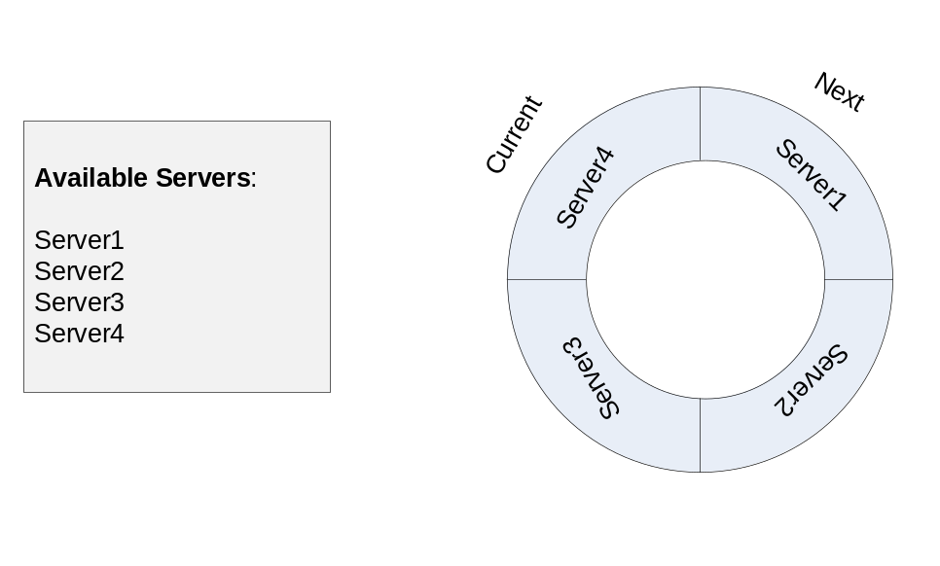
Figure 3

Round robin algorithm is simple, fast, and robust. It’s more suitable for static applications. Since it does not account for session state intelligence, it fails to support dynamic applications. Round robin algorithm can be used for dynamic applications in a specialized server cluster where back-end servers use a separate session state server. That way every server is able to respond to client requests and still work with the session state.

2.1.2.2. Weight based Load Balancing
Weight based load balancing technique uses round-robin request routing algorithm with a twist. In weight based load balancing, administrator assigns a relative weight to the server. Software application then routes requests based on assigned server weights. Like if a server weight between two servers is 5:2, algorithm will send five requests to first server and then rotate to second server two subsequent requests. This technique is useful if we have variable size servers in the cluster. Some will pull more weight while others will do less.
Weight based load balancing shares the same fast, simplicity, and robustness features as round-robin and does also share the same flaws. It’s more suitable for static applications then dynamic applications.

2.1.2.3. IP-Hash based Load Balancing
In IP-Hash based loading balancing, routing is done based on hash based indexing of requests. Typically a client’s source address is hashed to generate an integer and then integer is indexed with the server pool. This mechanism provides client affinity and session stickiness. Since client’s address is likely to remain same throughout a server session, same client address will generate same hash integer and then server pool index.

2.1.2.3.1. Modulo Hashing
This is the basic form of IP-hashing based load balancing technique. It’s often found in routers and switches as well. Requesting clients address is hashed and indexed against server pool size using modulus operator. The index is used to determine the target server as illustrated in Listing 2:

Listing 2
Ip_hash = hash(request.source_ip);
Index = Ip_hash mod server_pool.size

This technique has a serious robustness issue. If a server goes down and is removed from the pool, all clients re-mapped. With newer pool size indexes will be changed. Re-mapping also happens whenever a service is added to the pool. Due to this reason, this technique is not widely used for dynamic applications.

2.1.2.3.2. Consistent Hashing
Consistent hashing adds more robustness to IP hashing technique. Instead of using index to determine a server, in consistent hashing, we use a block technique. First we create integer range based service blocks for each server. Then we hash client’s source address to a number. We retrieve the server which serves that block and serve the client, as illustrated in figure 3.

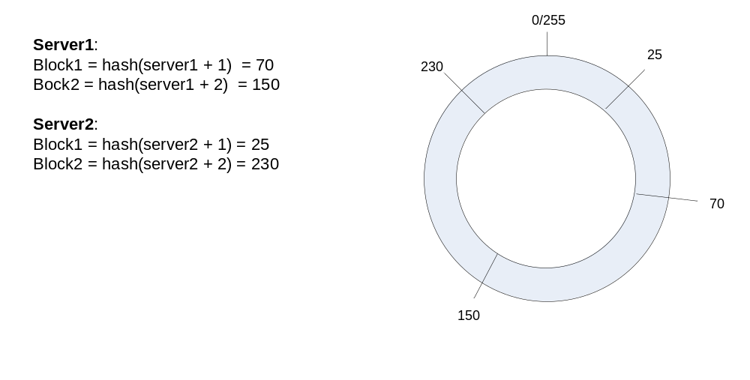
Figure 4. Figure assumes a 8-bit hash to illustrate. Normally there will be a 32bit hash. In a 32bit hash there are hundred or more server blocks to cover more surface area.

In this algorithm when a server goes down and is taken out of the pool, the client’s of that server are served by the next closest block server. This doesn’t impact all other clients like it does in module hashing. Similarly, if a new server is added into the pool, it will define its block and start serving some of the clients. Only clients that fall closer to that block will be re-mapped.

This is a popular technique and is often used by web cache servers or CDN’s like Akamai, memcache, and other. An optimized hashing algorithm with good distribution, speed, smoothness, balance is preferred.

2.1.2.4. Cookie based Load Balancing
Cookie based load balancing interjects a cookie in the response to the client on the way back. This special cookie is used to track the server assignment. Next time requests with this cookie will be sent to the assigned server. Server assignment for the first time can be made using round-robin or weighted approaches.
This is an efficient and robust technique for dynamic applications. If assigned server goes down only those clients are redirected to new server. By expiring load balancer cookies in certain time, like a day or so, load is redistributed across new servers in the pool if there has been any addition of any new resources.

3. Data Flow Diagrams (DFD)
3.1. Contextual Diagram

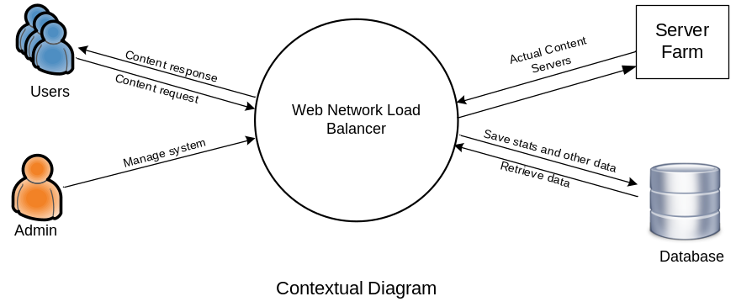
Figure 5

System contextual diagram above shows system’s interaction with external stimuli. There are four main components:

- Users: Users are the beneficiaries of the system. They are routed to the system by DNS or other proxy servers and then system based on certain contextual indicators serves the request from with-in its cluster. This communication is bi-directional.

- Admin: Administrators are the manager of the system. They configure, monitor, and control the system. They keep check on health of the overall system. Their communication can be bi-directional but actual commanding interface is one directional.

- Server Farm: Actual client request processing servers. These servers can have any network and system configuration. They have to be on the same network as web based network load balancer system.

- Database: Database is a central and crucial agent of the system. It saves the configuration information, logging and monitoring data, and other indicators. It may also work as communication component between the master and the slave components in the system. Database can be a stand-alone server outside the system, as illustrated, or just an add-on, embedded, component.

3.2. Level-1 Data Flow Diagram
IIS/
ASP.NET Pipeline
Load Balancing Module

Request Router
Backend Server

Config Console
Client
Admin
Database
Admin cmd
Content query
Content query
Select router
Route request
Process cmd
Save config

4. Entity Relationship Diagram (ERD)

Visual views
Persistence
Config Console

configures
Server List
Hostname
Port
Health Server
listens
Load Balancer
Web Traffic

uses

uses a
Routers

split traffic
between

Backend Server
Backend Server
Backend Server

Application Content
Database
Server
Request
Logs

Figure 7

5. Activity Diagram

5.1. Request Routing
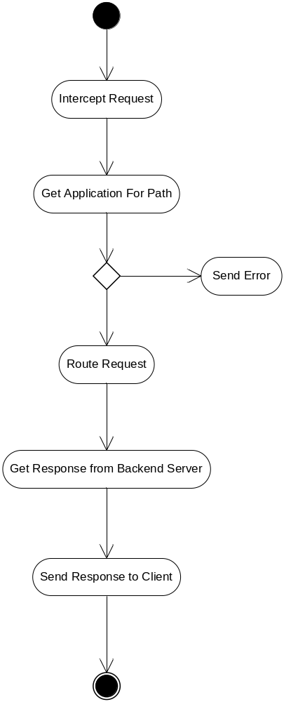
Figure 8

5.2. Configure System
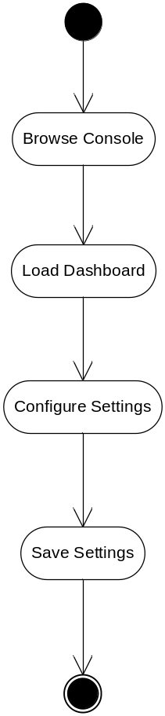
Figure 9

5.2. Round-Robin Router
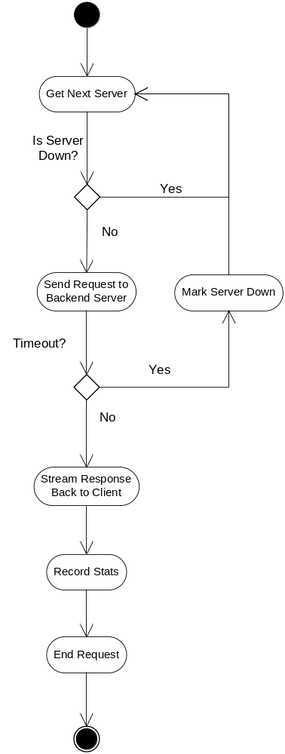
Figure 10

6. Sequence Diagrams

6.1. Process a request using round-robin router
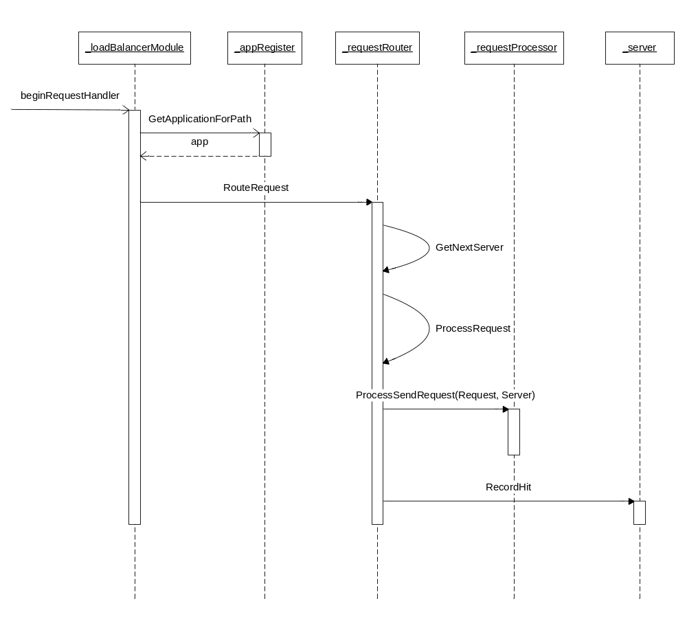
Figure 11

6.2. Add Application
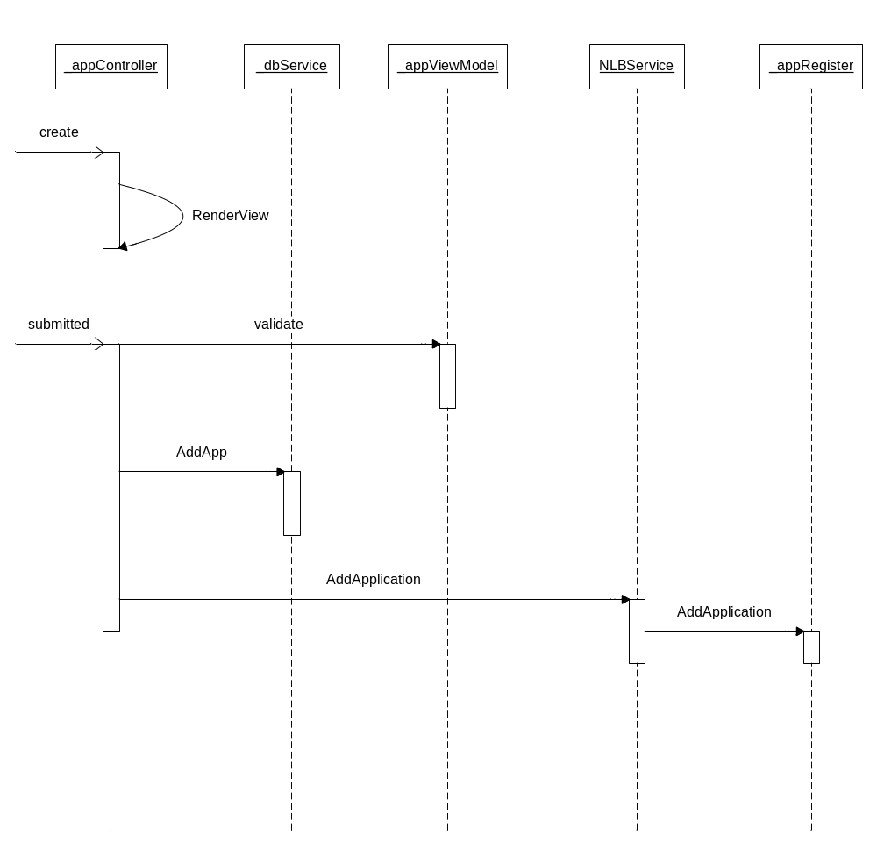
Figure 12

7. Architecture Design Diagram
WNLBv1.0
Configuration Console
Load Balancer Module

Servers Monitoring Thread
Server 1
Server 2
Presentation Layer
(ASP.NET MVC 4 based web app)

Server …n
Business Logic Layer
(View Models and Controllers)
App1
Router
Database Layer
(Entity Framework Based Models)
App2
Router

7.1. Architecture design diagram component details
# | Component | Description
1 | Load Balancer Module | This is one the basic module that actually contains all the routing logic. It’s going to be a separate DLL library.
2 | Server Monitoring Thread | This is the server health-check thread that monitors server connectivity periodically. It will mark servers available/unavailable based on their status.
3 | Server | Backend server record. Contains server connectivity information and stats.
4 | App | Application component that holds application settings including routing algorithm and server pool.
5 | Router | A request router capable of routing and processes requests. These terminate most of the requests for the system
6 | Configuration Console | A web-based password protected configuration console for admins.
7 | Presentation Layer | This layer is made using ASP.NET MVC 4 and Bootstrap technology that serves HTML, CSS, and JavaScript codes to the browsers.
8 | Business Logic Layer | Business rules are distributed across controllers from MVC and specialized view model classes from ASP.NET MVVM architecture.
9 | Database Layer | This layer consists of Microsoft Entity Framework 4 object relational layer.

